LAB EXPERIMENT RECORD
SET 18: PRODUCT INVENTORY MANAGEMENT
Department | AIDS
Course Code / Course Name | DSA0601 / Data Handling and Visualization
Experiment | Data Visualization using R
Name | B. Pallavi
Register Number | 192424243
Date | 13 October 2026
Day | Tuesday

AIM
To analyze product inventory quantities and prices using R and visualize inventory data.
DATASET
Product ID | Product Name | Quantity Available | Price ($)
1 | Product A | 250 | 20
2 | Product B | 175 | 15
3 | Product C | 300 | 18
PROGRAM 1: BAR CHART OF PRODUCT QUANTITIES
R Code
product <- c("Product A", "Product B", "Product C")
quantity <- c(250, 175, 300)
barplot(quantity,
names.arg = product,
main = "Product Inventory",
xlab = "Product",
ylab = "Quantity Available",
col = "lightblue")
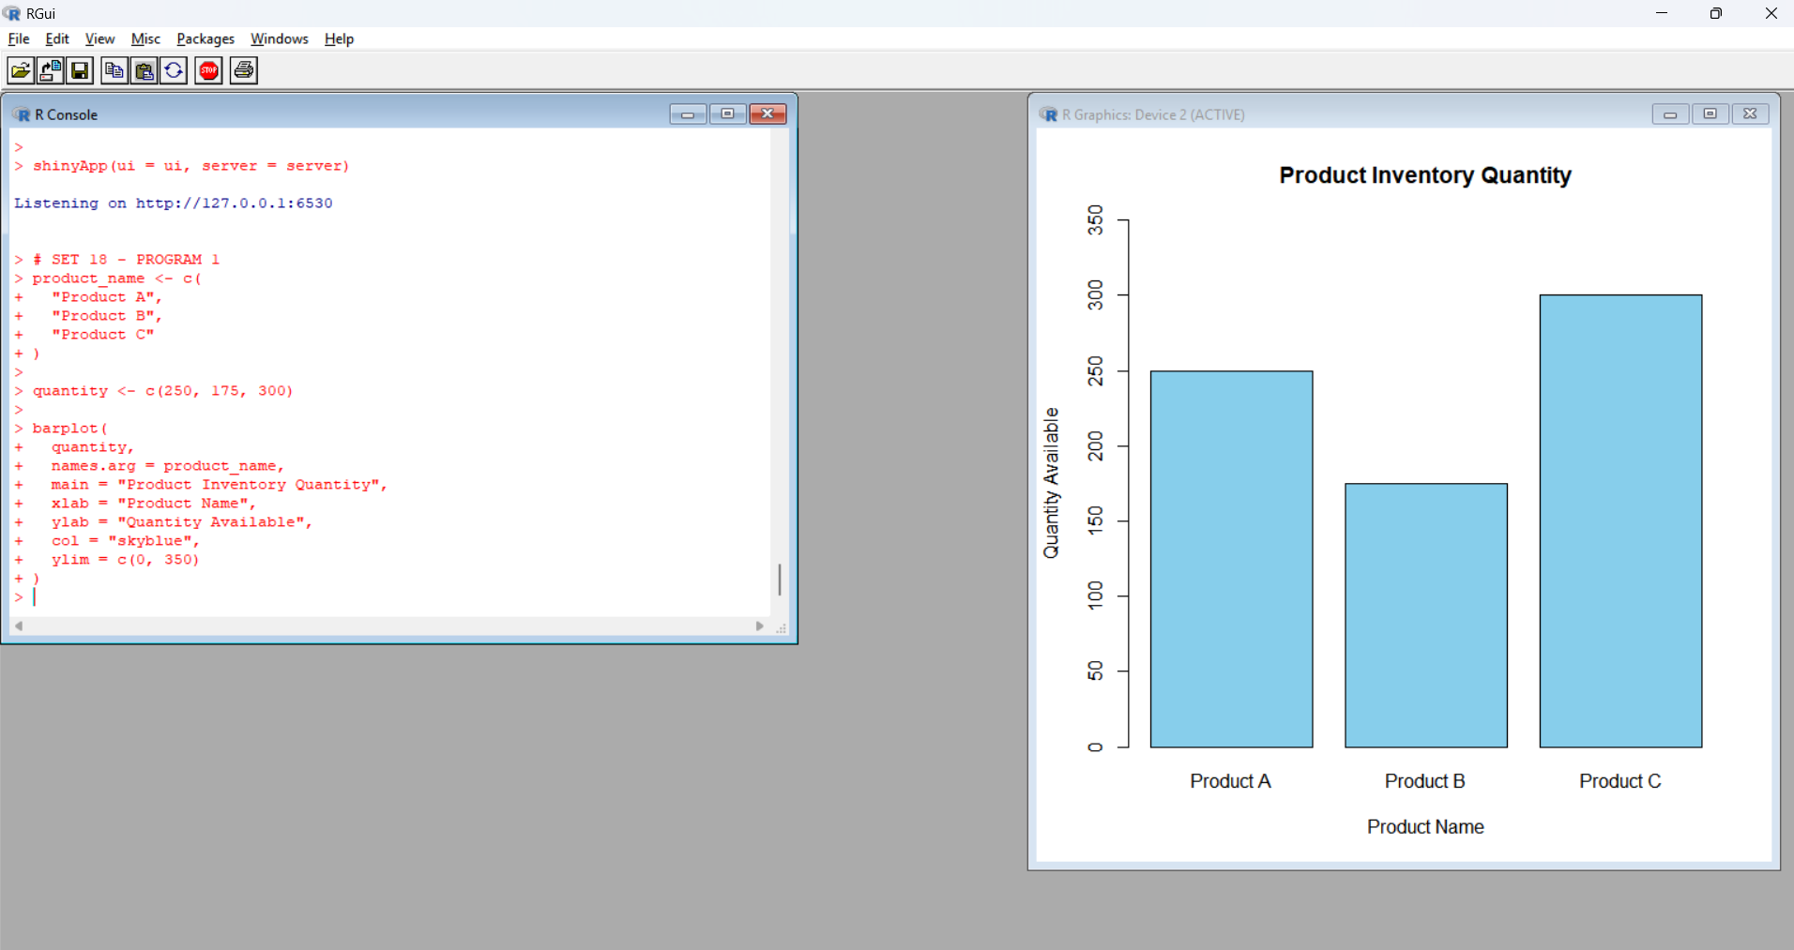Observation: Product C has the highest quantity of 300 units, while Product B has the lowest quantity of 175 units.
PROGRAM 2: STACKED BAR CHART OF PRODUCT CATEGORIES
R Code
category_quantity <- matrix(
c(150, 100,
75, 100,
180, 120),
nrow = 3,
byrow = TRUE
)
rownames(category_quantity) <- c(
"Product A", "Product B", "Product C"
)
colnames(category_quantity) <- c(
"Category 1", "Category 2"
)
barplot(t(category_quantity),
main = "Product Quantity by Category",
xlab = "Product",
ylab = "Quantity",
col = c("orange", "lightgreen"),
legend.text = TRUE,
beside = FALSE)
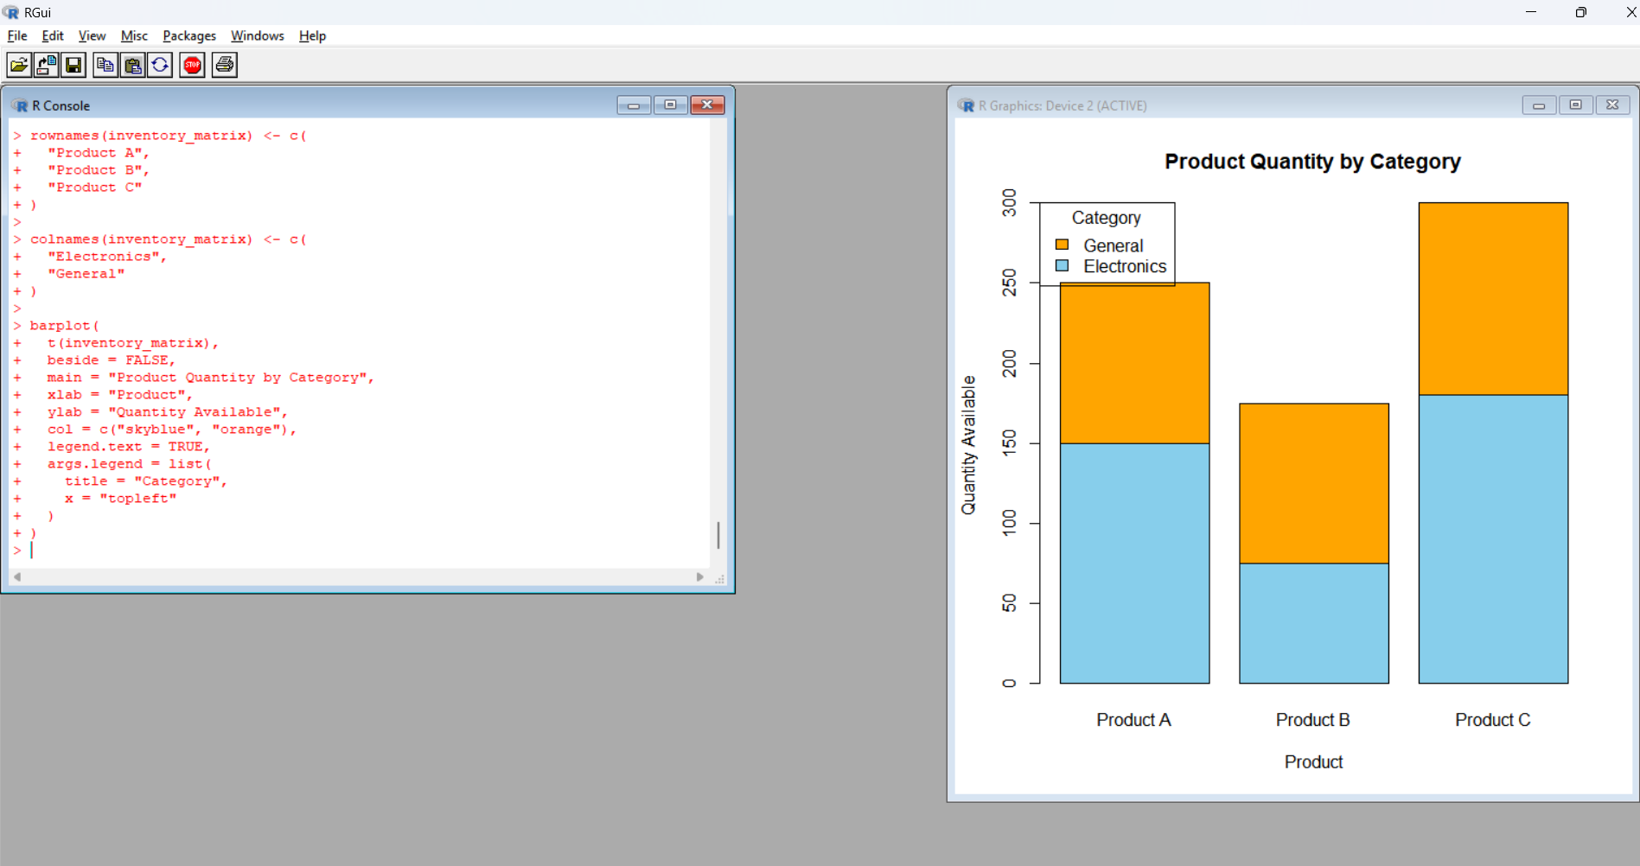
Observation: The stacked bar chart displays illustrative category quantities for each product. The category breakdown is an example because the original dataset does not contain category information.
PROGRAM 3: DISPLAY PRODUCT INVENTORY DATA
R Code
inventory_data <- data.frame(
Product_ID = c(1, 2, 3),
Product_Name = c("Product A", "Product B", "Product C"),
Quantity = c(250, 175, 300),
Price = c(20, 15, 18)
)
print(inventory_data)
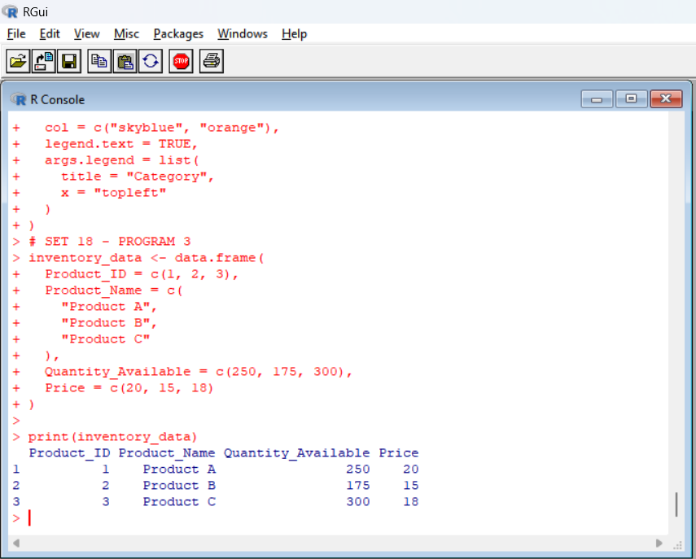
Observation: The data frame displays product IDs, product names, available quantities, and prices.
PROGRAM 4: CREATE A TABLEAU DASHBOARD
- Enter the product dataset into Excel.
- Save the file as Product_Inventory.xlsx.
- Open Tableau and connect to the Excel file.
- Create a bar chart showing available quantities by product.
- Create a stacked bar chart using actual product category quantities if available.
- Add the product inventory data table.
- Combine the visualizations into a dashboard.

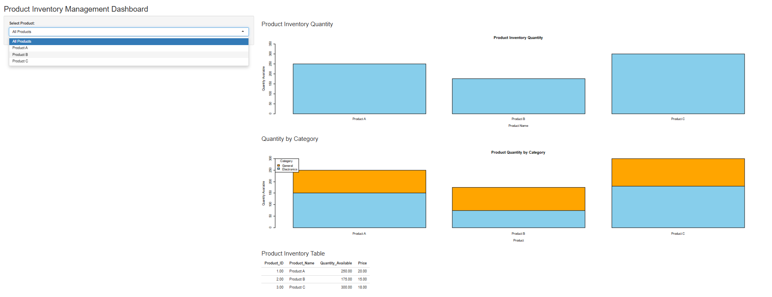
Observation: The dashboard provides an overview of product quantities, prices, and category-wise inventory when category data is available.
PROCEDURE
- Open R or RStudio.
- Enter the product inventory dataset.
- Execute each R program.
- Observe the generated charts and data table.
- Create the dashboard in Tableau.
RESULT
Product inventory data was analyzed successfully using R and Tableau. Bar charts, a stacked bar chart, and a data table were used to visualize product quantities and inventory details.

